Lecture 12

**ApacheServer**

**Webservers**

* 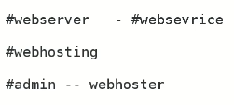
* Admin is webhoster à Admin will host the webpage.
* Webservers
  + Apache
  + Nginx
  + Many others …
* 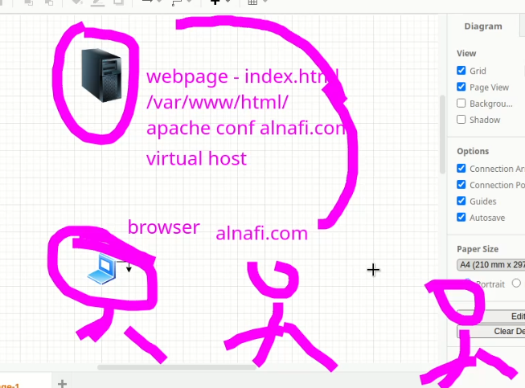

**Task**

* Apache web hosting
  + 1. Create or avail a webpage.
    2. Locate à document root path.
    3. host a website with path in **httpd.conf** file.
    4. map web site name with IP /etc/hosts
  + website hosting will be done.
* Apache can understand html by default.
* Default path for Apache à **/var/www/html**
* Move the webpage to this location. à **very Important !!!** name the page index.html or it will not work. I created the page with another name which created issues until I renamed it to “**index.html**”
* Main directory **/etc/httpd à** holds all config/supported files
* This is configuration file of Apache in **/etc/httpd/conf**
* 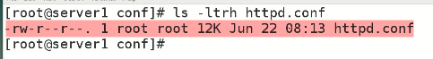

In 7 & 8 version virtual host is in Child Config file of this file.

* In conf.d directory, all files are child files
* 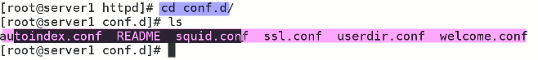
* .
* 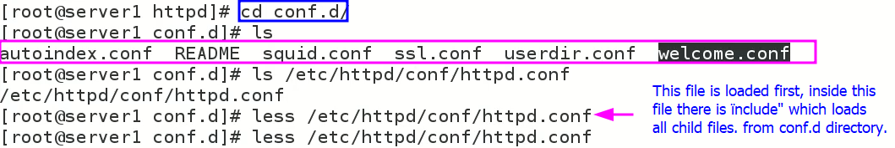
* .
* 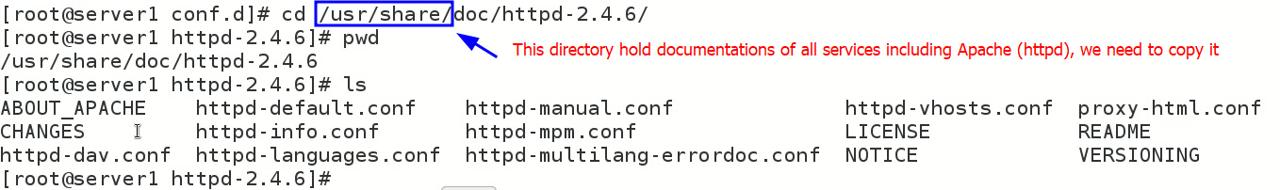
* .
* 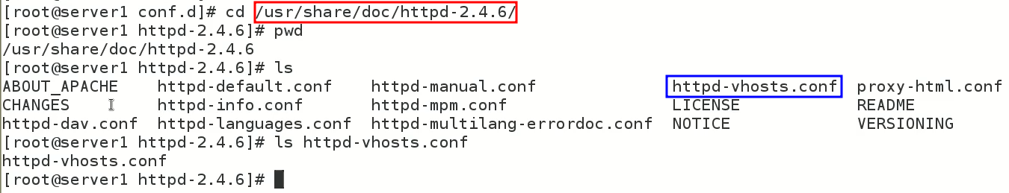
* Virtual Hosting is done in Sec 3
* 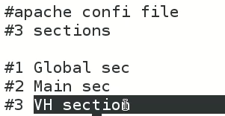
* we need to copy this file to /etc/httpd/conf.d
* $ cp httpd-vhosts.conf /etc/httpd/conf.d
* The go to à /etc/httpd/conf.d à locate vhosts.conf file and edit it
* $ vi vhosts.conf
* In the end of this file,
* 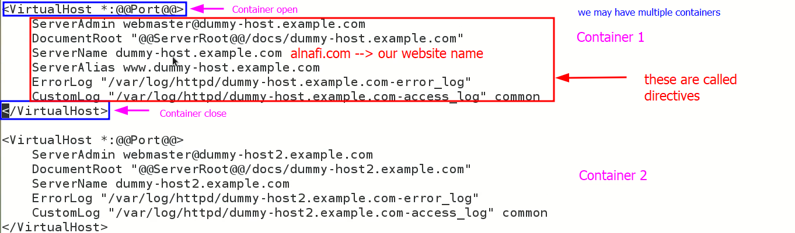
* 3 changes are to be made in Container 1
* 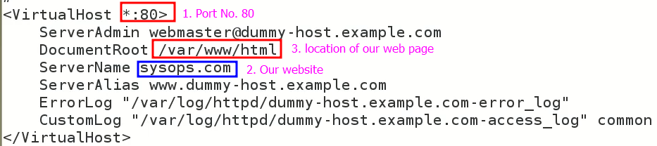
* Save & quit (:wq)
* Now, test httpd conf file à $ httpd -t
* 
* Now webhosting is done.
* Next,
* $ systemctl reload or <restart> httpd
* Make sure to enable it **$ systemctl enable httpd**
* **Now, open the browser and put IP of the server (our machine) in address bar.**
* Now check if webpage is opened???
* Working explained,
* 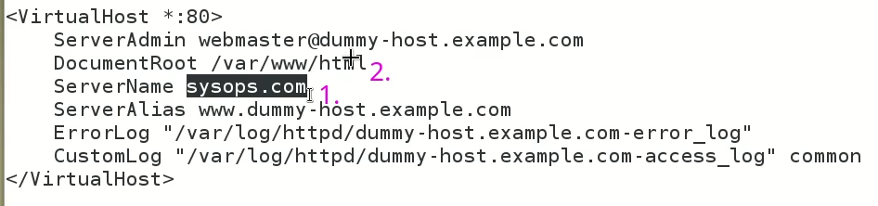
* First it checks the **ServerName** and then go to the **DocumentRoot** to load the webpage.

To open the webpage with name <website_name.com> à enter it into /etc/hosts,

* 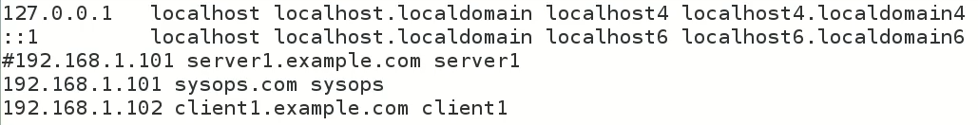
* how it works??
* 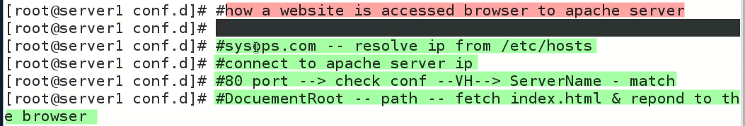
* **My webpage is working Alhamdulillah.**
* With domain name,
* .
* 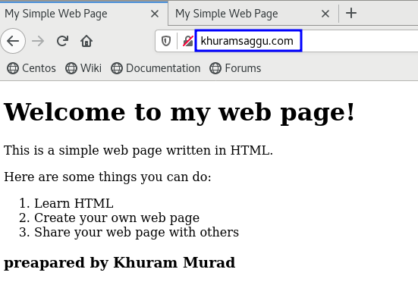
* With IP,
* Graphical user interface, text, application, email

  Description automatically generated